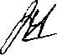

GREAT WAKERING COUNTY SECONDARY school
THE EIGHTH ANNUAL DISTRIBUTION OF PRIZES IN THE SCHOOL HALL
on TUESDAY, 20th JULY, 1965.
commencing at 8.Opm.
by
MR. P. J. KENNEDY,

PROGRAMME OF PROCEEDINGS
1. A. J. Belton, Esq., Chairman of the Governing Body;
2. Headmaster's Report;
3. Presentation of Prizes by Mrs. P. J. Kennedy;
4. Address by Mr. P. J. Kennedy;
5. Vote of Thanks
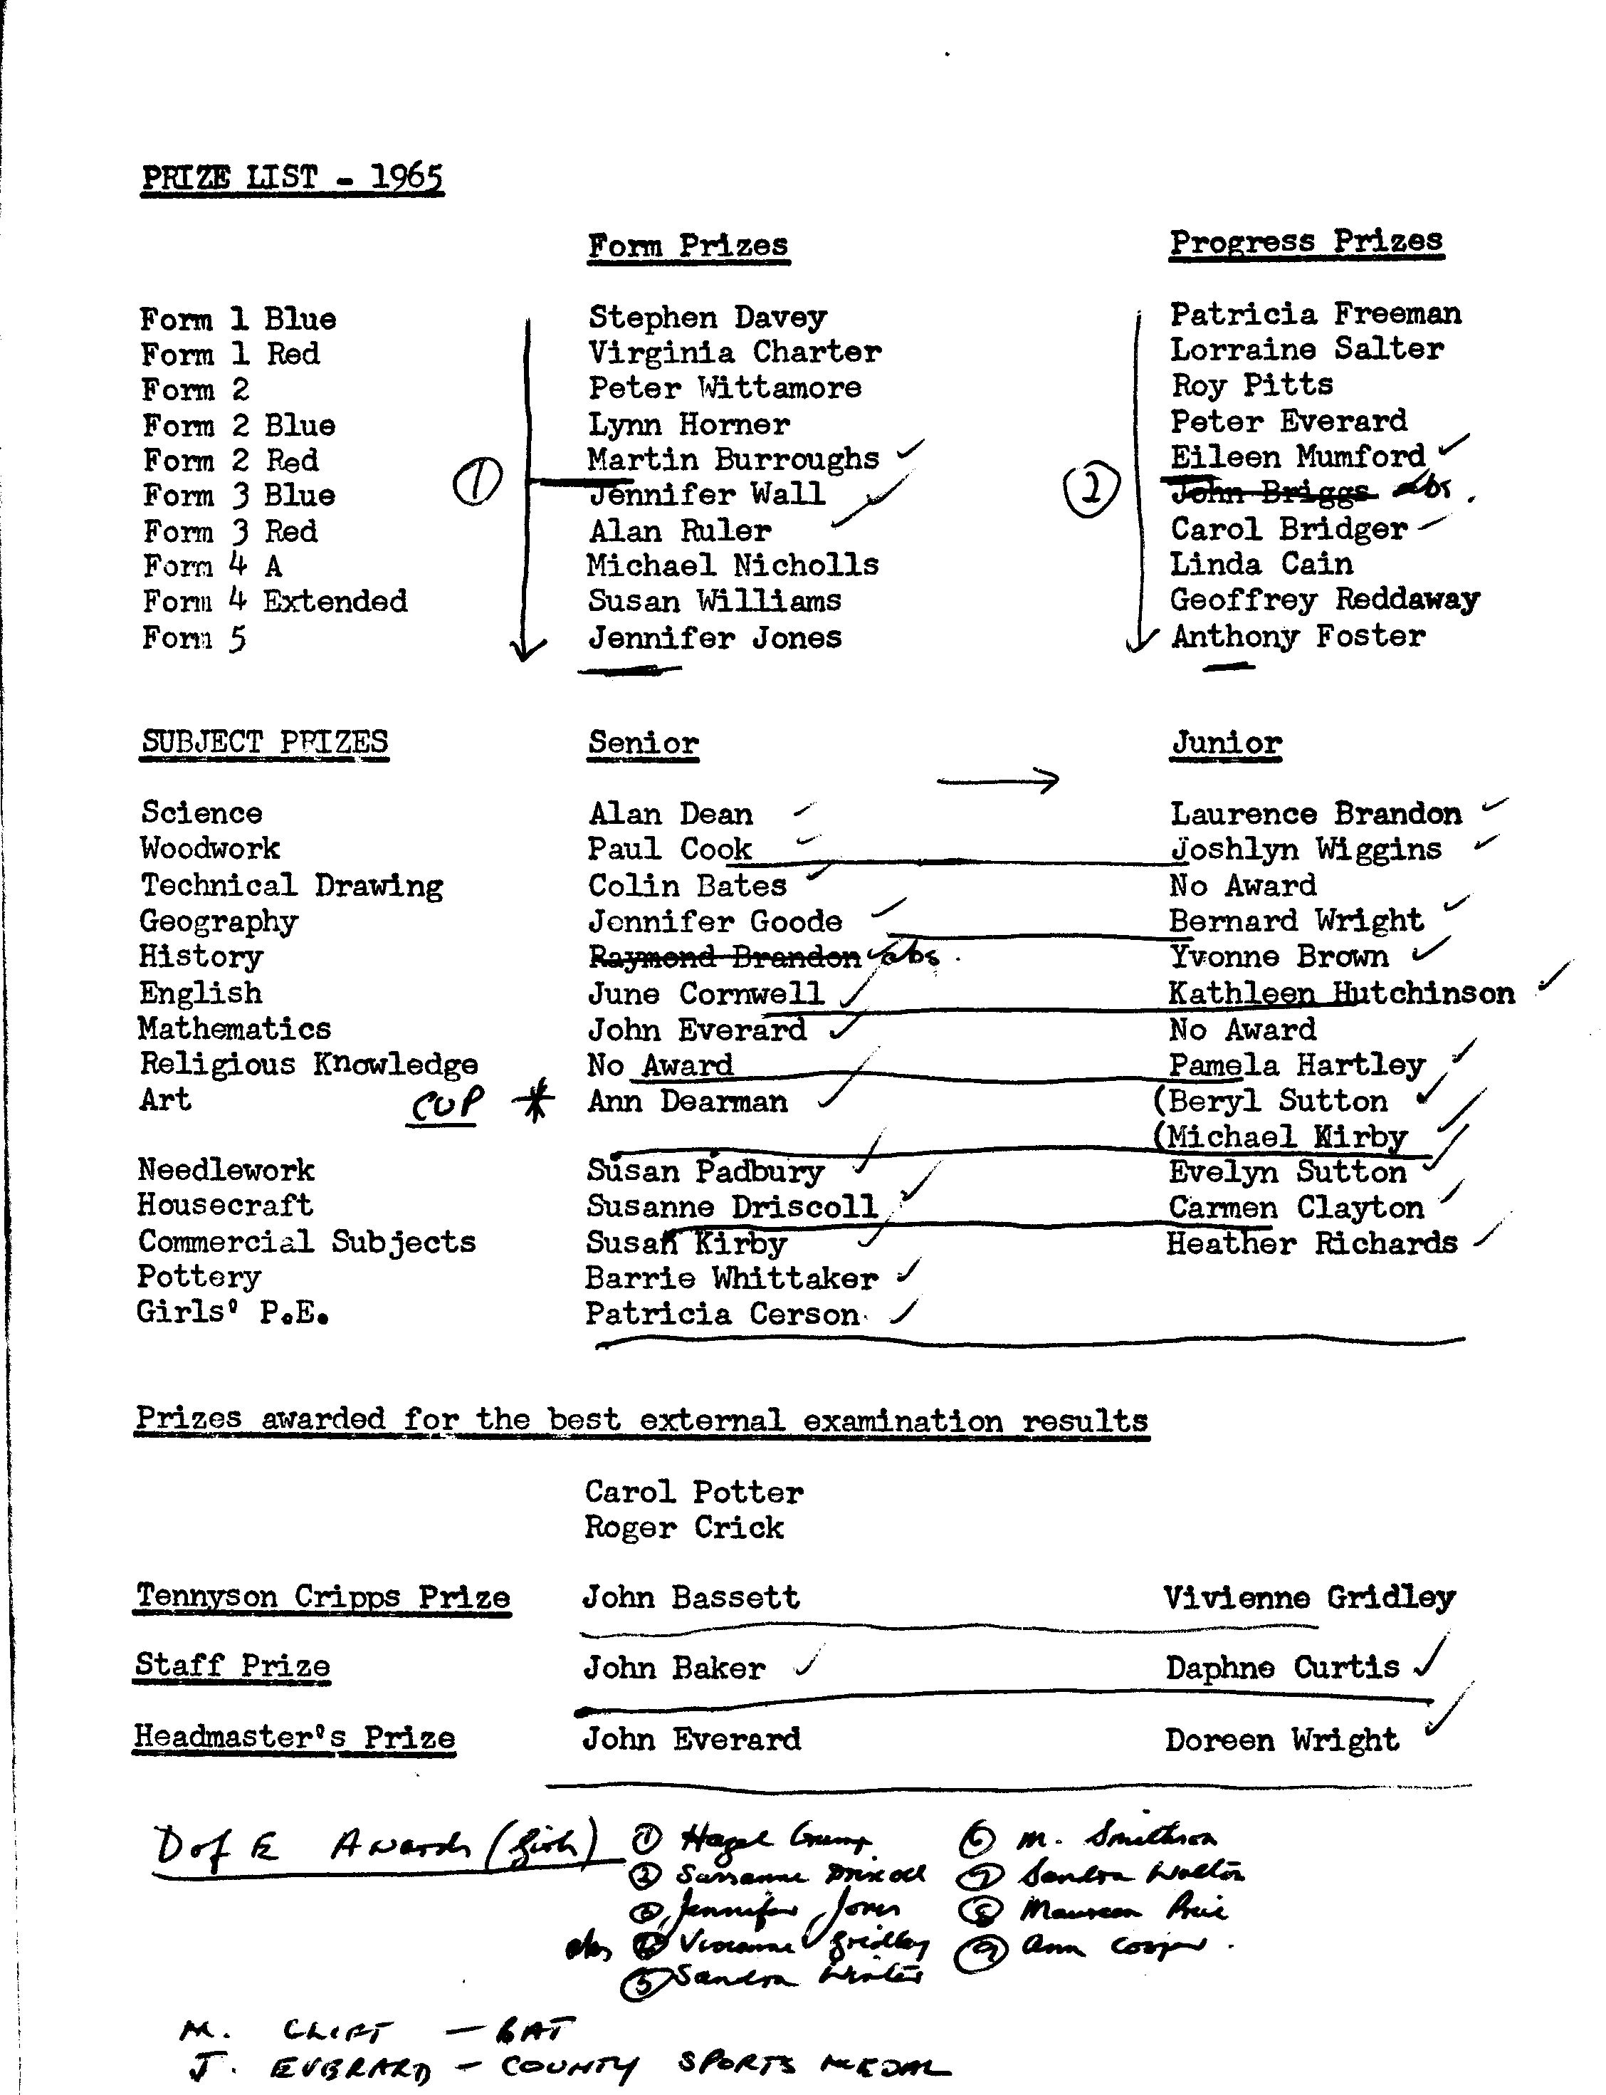
SPORTS AWARDS
FIELD EVENTS - BOYS.

UNDER 13 RESULTS
UNDER 14 RESULTS

High Jump
880 yds. Walk Barrie Whittaker
Long Jump
Shot
Javelin Discus
880 yds. Walk 1 Mile
UNDER
High Jump Long Jump JBrig Shot Javelin Discus
1 Mile
Terence Baker
Terence Baker
Terence Baker
Alan Foster
Terence Baker
Michael Scotton
Terence Baker
15 RESULTS
Barrie Whittaker
Stephen Burroughs David Shipp Stephen Baker
Barrie Whittaker

Stuart Greengrass Kelvin Swain _ Stuart Greengrass Peter Everard Peter Everard Roy Pitts Terence Smith
High Jump
Long Jump
Shot
Javelin
Discus
880 yds. Walk
1 Mile
UNDER 17 RESULTS
High Jump Michael Clift
Long Jump John Everard
Shot John Everard
Javelin Geoffrey Reddaway
Discus John Everard
880 yds. Walk Trevor Wlllsmer
1 Mile John Dick

FIELD EVENTS - GIRLS
UNDER 12 RESULTS
UNDER 13 RESULTS

High Jump Long Jump
UNDER 14
Anita Van der Linden High Jump Heather Mead Anita Van der Linden Long Jump Patricia Cerson
UNDER 16 RESULTS
RESULTS

High Jump Long Jump Discus

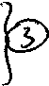
Rosemarie Devey Jane Kirby Mary Cambridge
High Jump Long Jump Discus
Sylvia Cornwell Sylvia Cornwell Irene Forbes

TRACK EVENTS - BOYS.
U. 14. 100 yds. Bernard Wright U. 17. 100 yds. Michael Clift
U. 13. 100 yds. Nicholas Cook
U. 15. 100 yds. John Briggs
U. 13. 880 yds. Terence Baker U_{e} 14. 880 yds. Terence Smith U. 15. 880 yds. Barrie Whittaker U. 17, 880 yds. John Dick U.13. 220 yds. Terence Baker U. 14. 220 yds. John Robinson U.15. 220 yds. John Bidggs U. 17. 220 yds. Michael Clift

TRACK EVENTS - BOYS (Cont'd)
U. 13. 440 yds. Terence Baker U. 14. 440 yds. Terence Smith
U. 15. 440 yds. Barrie Whittaker U. 17. 440 yds. Michael Clift
__ _ . ___ . BOYS RELAY - JUNIOR
Winning House - Green - Nore,
Team: B. Wright; T. Smith; N. Cook; K. Swain;
BOYS RELAY - SENIOR
Winning House - Red - Medway
Team: J. Dick; G. Reddaway; M. Waterhouse; P. Cook;

TRACK EVENTS - GIRLS U. 13. 75 yds. Susan Chaplin U. 13. 100 yds. Wendy Stammers U. 15. 100 yds. Mary Cambridge
U. 14. 150 yds. Patricia Cerson U. 17. 150 yds. Sandra Winter

330 yds. Junior Patricia Cerson
GIRLS RELAY - JUNIOR
U. 14. 100 yds. Patricia Cerson
U. 17. 100 yds. Irene Forbes
U. 15. 150 yds. Mary Cambridge
330 yds. Senior Irene Forbes

Winning House - Blue - Crowstone
Team W. Stammers; C. Abrey; Patricia Cerson; I. Clapp
GIRLS RELAY - SENIOR
Winning House - Red - Medway
Team I. Forbes; K. Devey; S. Kirby; J. Kirby.

PRESENTATION OF:-

Sports Medals Nicholls Rounders Cup

Laird Football Trophy Gre Kilworth r/up Fball Cup-Med

Cross Country Cup – Senior-Med Green Netball Cup-Nor
Mott Cricket Trophy-Med Adcock Athletic Cup-Cro
Cross Country Cup – Junior -Cro Ellis Triers’ Cup-Nor
Keen Games Shield-Nor/Med Governors’ House Cup-Med
York Athletic Trophy -Cro Jnr Netball-Map
6 aside Soccer k.o. Jnr-Map
6 aside Soccer k.o. Snr-Nor
Nore - Boy J Everard, Girl - Rosemary Devey
Medway – Boy G Reddaway, Girl – I Forbes
Crowstone - Boy T Baker, Girl P Cerson
Maplin – Boy M Clift, Girl M Cambridge

EXTERNAL EXAMINATIONS 1964 - 1965 G.C.E. "0” LEVEL PURE MATHEMATICS
Roger Crick William Sloan
G.C.E. "0” LEVEL PHYSICS
G.C.E. "0" LEVEL TECHNICAL DRAWING
G.C.E. “0” LEVEL DOMESTIC SCIENCE G.C.E. “O” LEVEL NEEDLEWORK G.C.E. “0" LEVEL ENGLISH LANGUAGE
Carol Potter
Roger Crick
Roger Crick David Sawyer
Carol Potter Carol Potter David Sawyer

R.S.A. SCHOOL CERTIFICATE-ENGLISH LANGUAGE

Peter Avery John Bassett Peter Brown Ann Cooper Roy Deeks Anthony Foster Peter Horner Susan Padbury Peter Robinson Stephen Todd Graham Wilkinson
Robert Avery Janet Bridger Michael Clift June Cornwell Susanne Driscoll Vivienne Gridley Jennifer Jones Eunice Petley Robert J. Smith Sandra Walton Sandra Winter
John Baker Bernard Brown Roger Crick Alan Dean John Everard Raymond Hockley Fiona McCombie Maureen Price David J_{e} Sutton Russell Willsmer

R.S.A. SCHOOL CERTIFICATE - ARITHMETIC

Peter Avery John Bassett Peter Brown June Cornwell John Everard Raymond Hockley Fiona McCombie Maureen Price Robert J. Smith Stephen Todd Sandra Winter
Robert Avery Janet Bridger Michael Clift Alan Dean Anthony Foster Stuart Holliday Susan Padbury Peter Robinson Margaret Smithson Sandra Walton Doreen Wright
John Baler Bernard Brown Ann Cooper Susanne Driscoll Vivienne Gridley Jennifer Jones Eunice Petley Robert Scott David J Sutton Russell Willsmer Jeannette Parker

R.S.A. SCHOOL CERTIFICATE - MATHEMATICS I
Peter Avery Robert Avery John Baker
John Bassett Janet Bridger Bernard Brown
Michael Clift Ann Cooper Alan Dean
Susanne Driscoll John Everard Anthony Foster
Vivienne Gridley Raymond Hockley Jennifer Jones
Fiona McCombie Susan Padbury Eunice Petley
Maureen Price Peter Robinson Robert Scott
Robert J. Smith Margaret Smithson Stephen Todd
Sandra Walton Russell Willsmer Graham Wilkinson
Sandra Winter
R.S.A. SCHOOL CERTIFICATE - MATHEMATICS II
John Baker Bernard Brown Michael Clift
June Cornwell Alan Dean John Everard
Anthony Foster Vivienne Gridley Raymond Hockley
Jennifer Jones Fiona McCombie Eunice Petley
David J. Sutton Stephen Todd Sandra Walton
Russell Willsmer Sandra Winter Doreen Wright
R.S.A. SCHOOL CERTIFICATE - GENERAL SCIENCE
Peter Avery Robert Avery Michael Clift
Alan Dean Roy Deeks John Everard
Anthony Foster Peter Horner Robert Scott
David J. Sutton Stephen Todd Russell Willsmer
Graham Wilkinson Doreen Wright
R.S.A. SCHOOL CERTIFICATE - PHYSICS
Alan Dean John Everard Russell Willsmer
R.S.A. SCHOOL CERTIFICATE - GEOMETRICAL & TECHNICAL DRAWING
John Baker John Bassett Bernard Brown
Peter Brown Roger Crick Alan Dean
John Everard Raymond Hockley David Sawyer
Stephen Todd Russell Willsmer
R.S.A. SCHOOL CERTIFICATE - COOKERY & NUTRITION
Christine Flack Christina Keates Fiona McCombie
Doreen Wright
R.S.A. SHORTHAND 60 w.p.m.
Passed Linda Heard Denise Kiss
R.S.A. TYPEWRITING STAGE I
Passed with Credit Linda Heard Denise Kiss

R.S.A. STAGE I - ARITHMETIC Passed with Credit
Passed
John Dick Keith Pead
Heather Richards Ian Drennan Anthony Day Geoffrey Reddaway Christine Petley Anthony Quinnell Mary Thomas Susan Clark June Cornwell Clive Herbert
Stephen Kiss Trevor Willsmer
Barbara Milbourn Wendy Burles Sylvia Cornwell Robert Whittaker Jennifer Baynes William Cornwell Susan Williams Trevor Smith Ann Dearman Irene Forbes

R.S.A. STAGE II - ARITHMETIC 1st Class Pass
2nd Class Pass
R.S.A. STAGE I - MATHEMATICS Passed with Credit
Passed
William Sloan Roger Crick Denise Kiss
Graham Wilkinson
Alan Dean John Everard Michael Clift
Raymond Hockley Jennifer Jones Doreen Wright Robert Avery Eunice Petley Robert Scott
David Sawyer Linda Heard Carol Potter
Bernard Brown John Baker
Anthony Foster Susan Padbury Sandra Winter Russell Willsmer Stephen Todd Margaret Smithson

R.S.A. STAGE I - ENGLISH LANGUAGE

Passed
David Pengelly Sylvia Cornwell Barbara Milbourn Susan Kirby Trevor Willsmer June Cornwell Anthony Day
David A. Sutton Marilyn Smith Susan Williams Stephen Kiss Geoffrey Reddaway Robert Whittaker

