Great Wakering Secondary Modern School

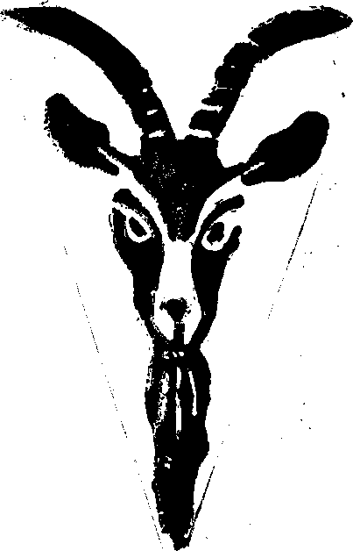
'
The Red Velvet Goat
A Mexican Folk Play by Josephina Niggli
This is not a play nor a revue skit, nor anything such as is generally seen on the English speaking stage. It comes from the Spanish Theatre, and is called "saenete".
The true "saenete" is simply a picture of what we call the "lower classes" lifted from reality to the stage. It is written in poetic dialogue, it is a comedy, and it has a romantic flavour.
When a Mexican goes to a play he goes, not as a spectator, but with the firm intention of being as much a part of the drama as the actors on the stage. It is the prompter, however, who bears the full burden of the performance, and so, to him, health and wealth.

C A S T

Estaban (who longs to own a goat)
Mariana (his wife)
Lorenzo (their son)
Lola ) (village girls, friends
Carmen ) of Ester)
Ester (a village girl, with whom Lorenso is in love)
Ramon (a Pedlar of women’s clothing)

Don Pepe (the Mayor of the village)
Dona Berta (Grand lady of the village) Other Villagers:-
Janes Templeton Kathleen Davey John Halfhide Jennifer Taylor Jeanne Prior Jacqueline Morris
Barry Burles
Brian Harbisher
Margaret Sutton
Linda Nicholls
Jennifer Berry Pearl Deeks
Ann Coker
Mary Topley
Evelyn Walton
Lois Matthews Margaret Willsmore John Murrell
Tony Stamp
John Farr
David Manton
John Glen

Scene – Estaban’s house on the Street of the Arches in the Town of the Three Marys.
Time - Six o'clock of an afternoon in July. The Present.

