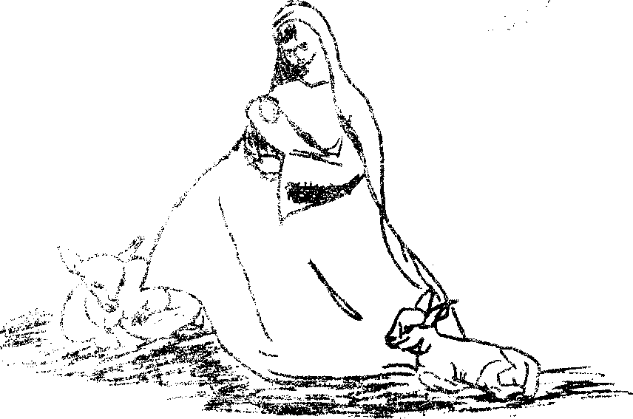

A Nativity Play
A NATIVITY PLAY

Prologue spoken by
Eastern Kings
Mary
Anne (the Mother of Mary)
Ruth (a Neighbour of Anne)
The Angel Gabriel
Joseph (the spouse of Mary)
Barnabas }
Nathaniel
Merchants
Obadiah
Ezra
Shepherds
Ben-Ezra
Zachary
An Innkeeper
A Serving Maid
Gaspar )
Balthasar
Melchior
Linda Heard Winnie Brierley Maureen Smith Michele Bradley Clive Frieland Michael Salmons David Clift Frederick Boreham Raymond Chittock Michael Matthews Robert Avery David Lee
Russell Willsmere
Susan Gabell Colin Mayhew Peter Horner Michael Clift

Angels
Carol Potter Jane Everitt Doreen Witham Fiona McCombie Maureen Price Francis Briggs Denise Kiss William Cornwell
Christine Petley Linda Hartley Jennifer Baynes Vivienne Gridley Susan Rose Cynthia Witton
Anthony Quinnell

Merchants
John Pengelly John Burroughs Keith Bradley Graham Ashley
Roy Deeks Roger Crick
Lighting Curtains
SYNOPSIS OF SCENES
Prologue
Scene I
Scene II
Scene III
Scene IV
Scene V
Scene VI
Epilogue
Tableau
Roger Abrey
Colin Mead
Ivan Watts
Stephen Topley
Geoffrey Webb
David Sawyer
The Home of Mary at Nazareth The hills near Bethlehem An Inn near Bethlehem The hills near Bethlehem The Stable of the Inn The Stable of the Inn

The audience are asked to stand and join in with the singing of '0 Come All Ye Faithful'.

